[Skip to content](https://learning.oreilly.com/library/view/Core+Java+Volume+I%E2%80%94Fundamentals,+Eleventh+Edition/9780135167199/chapter12_images.xhtml" \l "container)

* [Home](https://learning.oreilly.com/home/)
  + [Your O'Reilly](https://learning.oreilly.com/library/view/Core+Java+Volume+I%E2%80%94Fundamentals,+Eleventh+Edition/9780135167199/chapter12_images.xhtml)
    - [Profile](https://learning.oreilly.com/profile/)
    - [History](https://learning.oreilly.com/history/)
    - [Playlists](https://learning.oreilly.com/playlists/)
    - [Highlights](https://learning.oreilly.com/u/f4e759e3-0315-4150-8d73-1e18e743d0c8/)
  + [Featured](https://learning.oreilly.com/library/view/Core+Java+Volume+I%E2%80%94Fundamentals,+Eleventh+Edition/9780135167199/chapter12_images.xhtml)
    - [Navigating Change](https://learning.oreilly.com/navigate-change/)
    - [For Government](https://learning.oreilly.com/featured/governing-change/)
    - [Recommended](https://learning.oreilly.com/recommendations/)
  + [Explore](https://learning.oreilly.com/library/view/Core+Java+Volume+I%E2%80%94Fundamentals,+Eleventh+Edition/9780135167199/chapter12_images.xhtml)
    - [All Topics](https://learning.oreilly.com/topics/)
    - [Early Releases](https://learning.oreilly.com/search/?query=&extended_publisher_data=true&highlight=true&include_assessments=false&include_case_studies=true&include_courses=true&include_orioles=true&include_playlists=true&include_collections=true&include_notebooks=true&is_academic_institution_account=false&source=user&formats=book&sort=publication_date&facet_json=true&page=0)
    - [Shared Playlists](https://learning.oreilly.com/playlists/discover/)
    - [Most Popular Titles](https://learning.oreilly.com/search/?query=&extended_publisher_data=true&highlight=true&include_assessments=false&include_case_studies=true&include_courses=true&include_orioles=true&include_playlists=true&include_collections=true&include_notebooks=true&is_academic_institution_account=false&source=user&formats=book&formats=case%20study&formats=learning%20path&formats=live%20online%20training&formats=notebook&formats=oriole&formats=video&sort=popularity&facet_json=true&page=0&collection_type=expert)
    - [Resource Centers](https://learning.oreilly.com/resource-centers/)
  + [Settings](https://learning.oreilly.com/u/preferences/)
  + [Support](https://learning.oreilly.com/public/support/)
  + [Sign Out](https://learning.oreilly.com/accounts/logout/)

[Table of Contents for](https://learning.oreilly.com/library/view/Core+Java+Volume+I%E2%80%94Fundamentals,+Eleventh+Edition/9780135167199/chapter12_images.xhtml)

[Core Java Volume I—Fundamentals, Eleventh Edition](https://learning.oreilly.com/library/view/Core+Java+Volume+I%E2%80%94Fundamentals,+Eleventh+Edition/9780135167199/chapter12_images.xhtml)

* [Search in book...](https://learning.oreilly.com/library/view/Core+Java+Volume+I%E2%80%94Fundamentals,+Eleventh+Edition/9780135167199/chapter12_images.xhtml)

Top of Form

Bottom of Form

* [Toggle Font Controls](https://learning.oreilly.com/library/view/Core+Java+Volume+I%E2%80%94Fundamentals,+Eleventh+Edition/9780135167199/chapter12_images.xhtml)

[PREVPrevious Chapter](https://learning.oreilly.com/library/view/core-java-volume/9780135167199/chapter11_images.xhtml)

[Code Snippets](https://learning.oreilly.com/library/view/core-java-volume/9780135167199/chapter11_images.xhtml)

[NEXTNext Chapter](https://learning.oreilly.com/library/view/core-java-volume/9780135167199/chapter13_images.xhtml)

[Code Snippets](https://learning.oreilly.com/library/view/core-java-volume/9780135167199/chapter13_images.xhtml)

[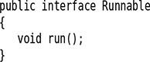](https://learning.oreilly.com/library/view/Core+Java+Volume+I%E2%80%94Fundamentals,+Eleventh+Edition/9780135167199/chapter12.xhtml#p0734_01)

[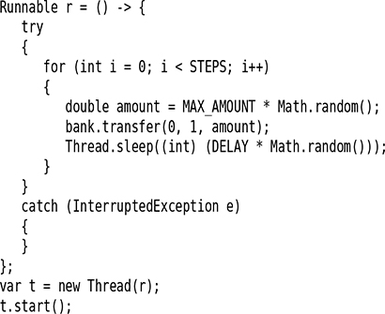](https://learning.oreilly.com/library/view/Core+Java+Volume+I%E2%80%94Fundamentals,+Eleventh+Edition/9780135167199/chapter12.xhtml#p0735_04)

[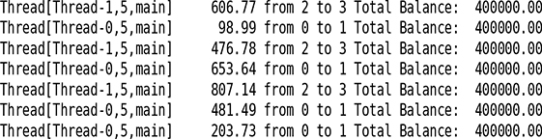](https://learning.oreilly.com/library/view/Core+Java+Volume+I%E2%80%94Fundamentals,+Eleventh+Edition/9780135167199/chapter12.xhtml#p0735_05)



[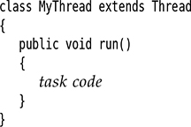](https://learning.oreilly.com/library/view/Core+Java+Volume+I%E2%80%94Fundamentals,+Eleventh+Edition/9780135167199/chapter12.xhtml#p0736_02)

[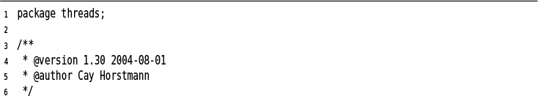](https://learning.oreilly.com/library/view/Core+Java+Volume+I%E2%80%94Fundamentals,+Eleventh+Edition/9780135167199/chapter12.xhtml#c12lis01)

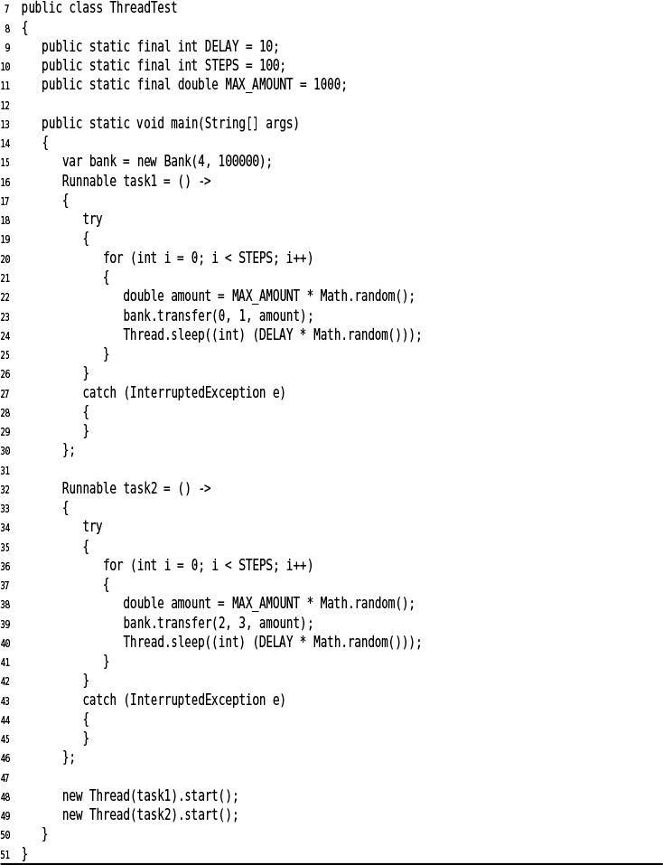

[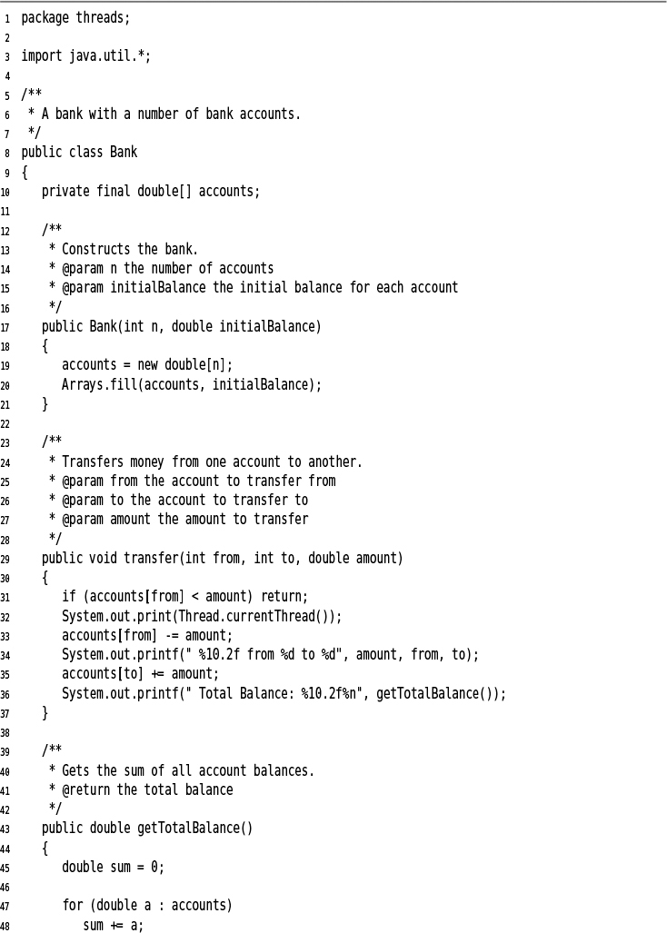](https://learning.oreilly.com/library/view/Core+Java+Volume+I%E2%80%94Fundamentals,+Eleventh+Edition/9780135167199/chapter12.xhtml#c12lis02)

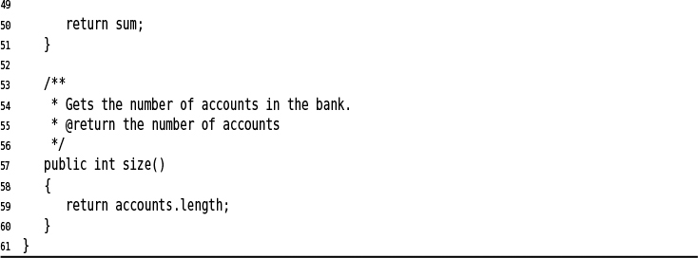

[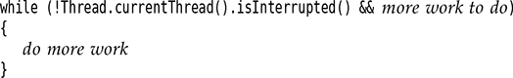](https://learning.oreilly.com/library/view/Core+Java+Volume+I%E2%80%94Fundamentals,+Eleventh+Edition/9780135167199/chapter12.xhtml#p0744_01)

[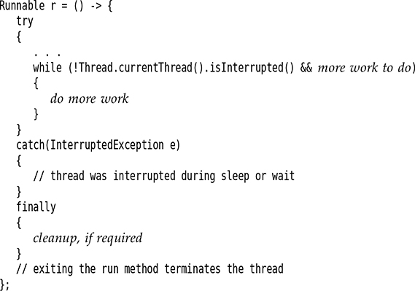](https://learning.oreilly.com/library/view/Core+Java+Volume+I%E2%80%94Fundamentals,+Eleventh+Edition/9780135167199/chapter12.xhtml#p0744_02)

[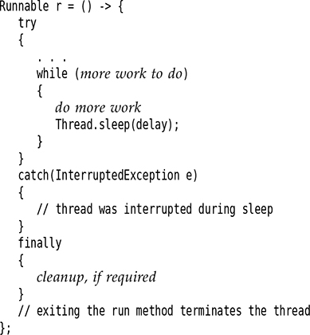](https://learning.oreilly.com/library/view/Core+Java+Volume+I%E2%80%94Fundamentals,+Eleventh+Edition/9780135167199/chapter12.xhtml#p0745_01)

[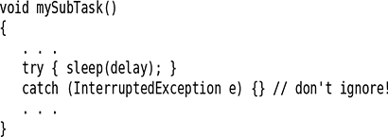](https://learning.oreilly.com/library/view/Core+Java+Volume+I%E2%80%94Fundamentals,+Eleventh+Edition/9780135167199/chapter12.xhtml#p0745_02)

[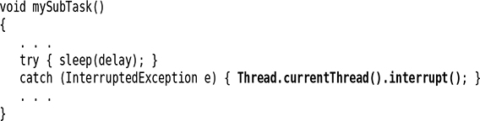](https://learning.oreilly.com/library/view/Core+Java+Volume+I%E2%80%94Fundamentals,+Eleventh+Edition/9780135167199/chapter12.xhtml#p0746_01)

[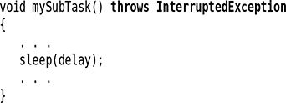](https://learning.oreilly.com/library/view/Core+Java+Volume+I%E2%80%94Fundamentals,+Eleventh+Edition/9780135167199/chapter12.xhtml#p0746_02)

[](https://learning.oreilly.com/library/view/Core+Java+Volume+I%E2%80%94Fundamentals,+Eleventh+Edition/9780135167199/chapter12.xhtml#p0747_02)

[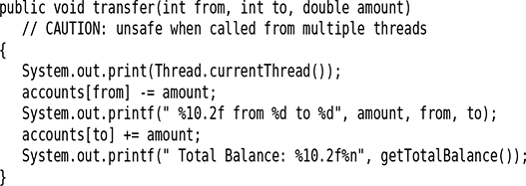](https://learning.oreilly.com/library/view/Core+Java+Volume+I%E2%80%94Fundamentals,+Eleventh+Edition/9780135167199/chapter12.xhtml#p0750_01)

[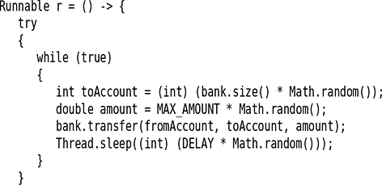](https://learning.oreilly.com/library/view/Core+Java+Volume+I%E2%80%94Fundamentals,+Eleventh+Edition/9780135167199/chapter12.xhtml#p0750_02)

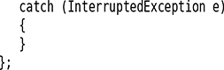

[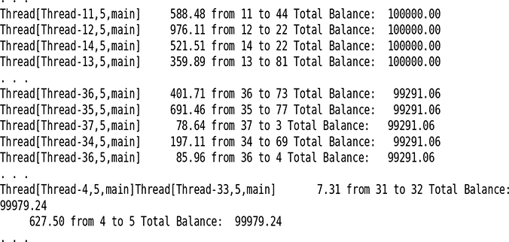](https://learning.oreilly.com/library/view/Core+Java+Volume+I%E2%80%94Fundamentals,+Eleventh+Edition/9780135167199/chapter12.xhtml#p0751_02)

[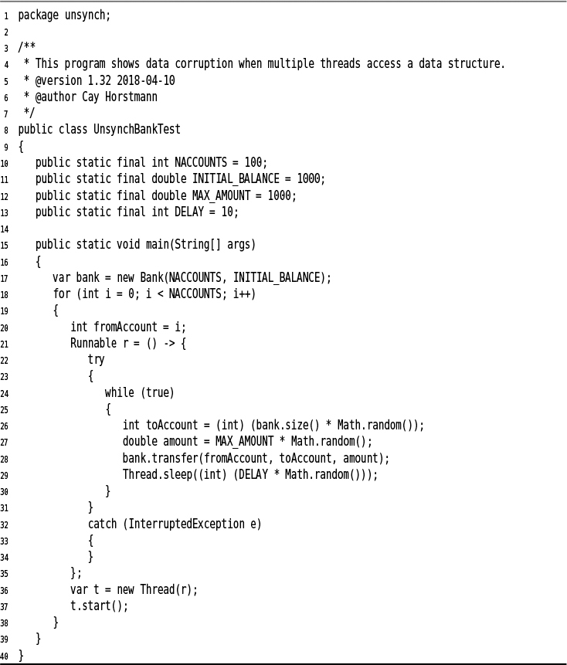](https://learning.oreilly.com/library/view/Core+Java+Volume+I%E2%80%94Fundamentals,+Eleventh+Edition/9780135167199/chapter12.xhtml#c12lis03)

[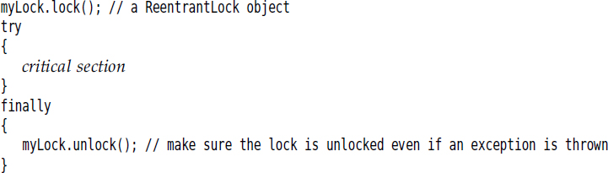](https://learning.oreilly.com/library/view/Core+Java+Volume+I%E2%80%94Fundamentals,+Eleventh+Edition/9780135167199/chapter12.xhtml#p0755_01)

[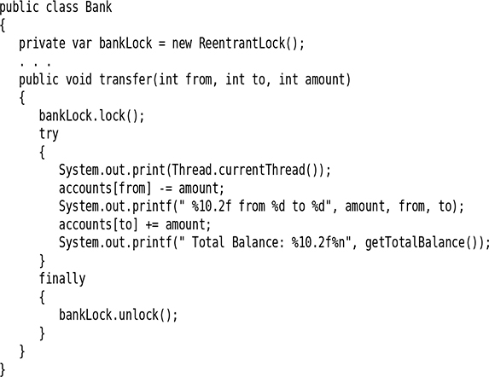](https://learning.oreilly.com/library/view/Core+Java+Volume+I%E2%80%94Fundamentals,+Eleventh+Edition/9780135167199/chapter12.xhtml#p0756_01)

[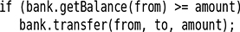](https://learning.oreilly.com/library/view/Core+Java+Volume+I%E2%80%94Fundamentals,+Eleventh+Edition/9780135167199/chapter12.xhtml#p0758_01)

[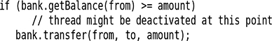](https://learning.oreilly.com/library/view/Core+Java+Volume+I%E2%80%94Fundamentals,+Eleventh+Edition/9780135167199/chapter12.xhtml#p0759_01)

[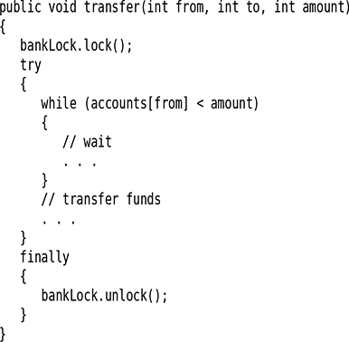](https://learning.oreilly.com/library/view/Core+Java+Volume+I%E2%80%94Fundamentals,+Eleventh+Edition/9780135167199/chapter12.xhtml#p0759_02)

[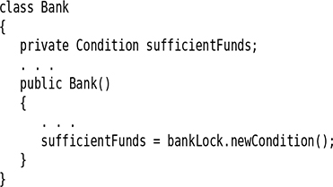](https://learning.oreilly.com/library/view/Core+Java+Volume+I%E2%80%94Fundamentals,+Eleventh+Edition/9780135167199/chapter12.xhtml#p0759_03)

[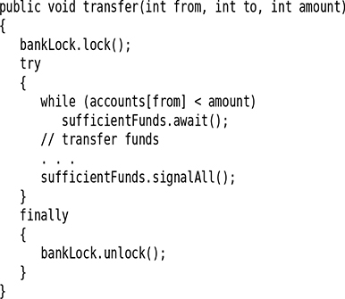](https://learning.oreilly.com/library/view/Core+Java+Volume+I%E2%80%94Fundamentals,+Eleventh+Edition/9780135167199/chapter12.xhtml#p0761_01)

[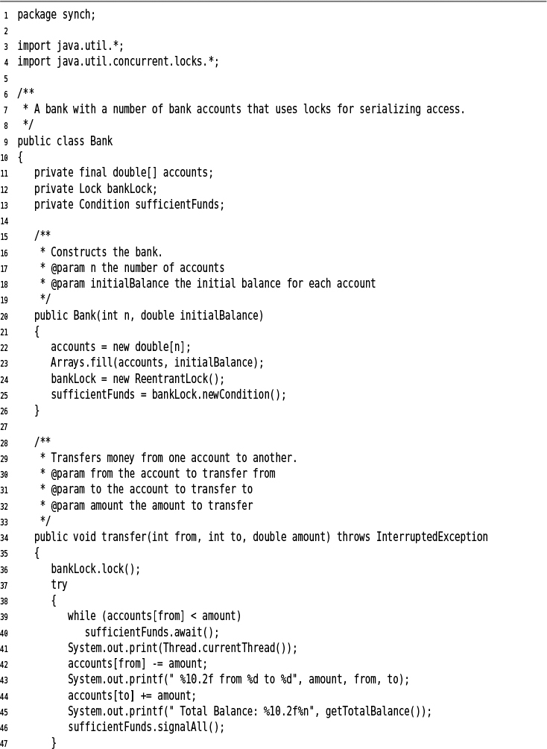](https://learning.oreilly.com/library/view/Core+Java+Volume+I%E2%80%94Fundamentals,+Eleventh+Edition/9780135167199/chapter12.xhtml#c12lis04)

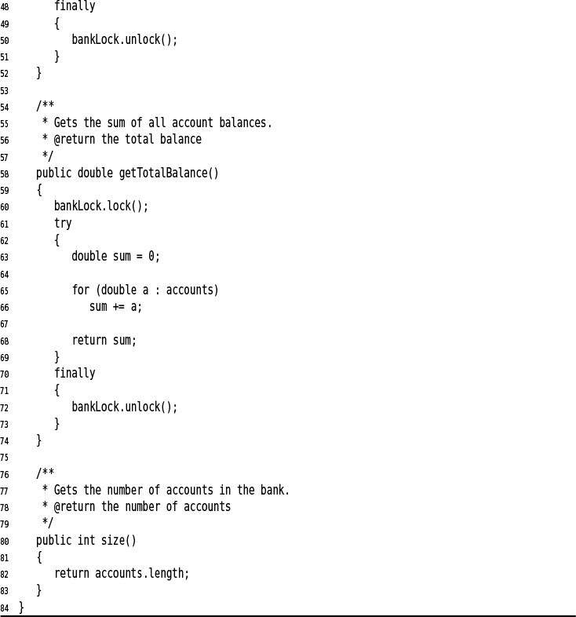

[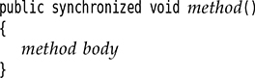](https://learning.oreilly.com/library/view/Core+Java+Volume+I%E2%80%94Fundamentals,+Eleventh+Edition/9780135167199/chapter12.xhtml#p0764_01)

[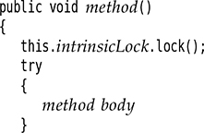](https://learning.oreilly.com/library/view/Core+Java+Volume+I%E2%80%94Fundamentals,+Eleventh+Edition/9780135167199/chapter12.xhtml#p0764_02)

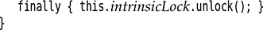

[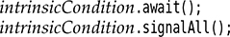](https://learning.oreilly.com/library/view/Core+Java+Volume+I%E2%80%94Fundamentals,+Eleventh+Edition/9780135167199/chapter12.xhtml#p0765_02)

[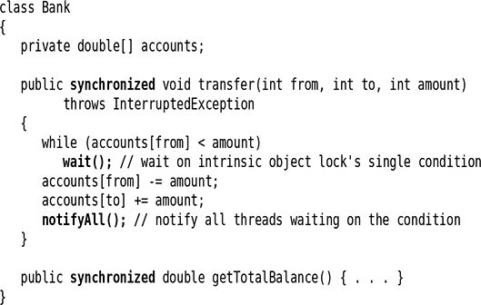](https://learning.oreilly.com/library/view/Core+Java+Volume+I%E2%80%94Fundamentals,+Eleventh+Edition/9780135167199/chapter12.xhtml#p0765_03)

[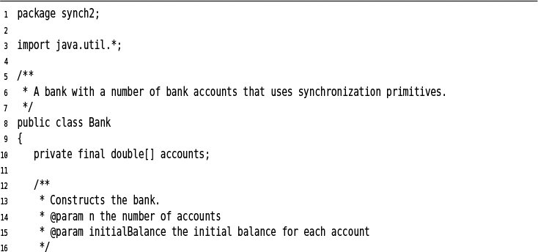](https://learning.oreilly.com/library/view/Core+Java+Volume+I%E2%80%94Fundamentals,+Eleventh+Edition/9780135167199/chapter12.xhtml#c12lis05)

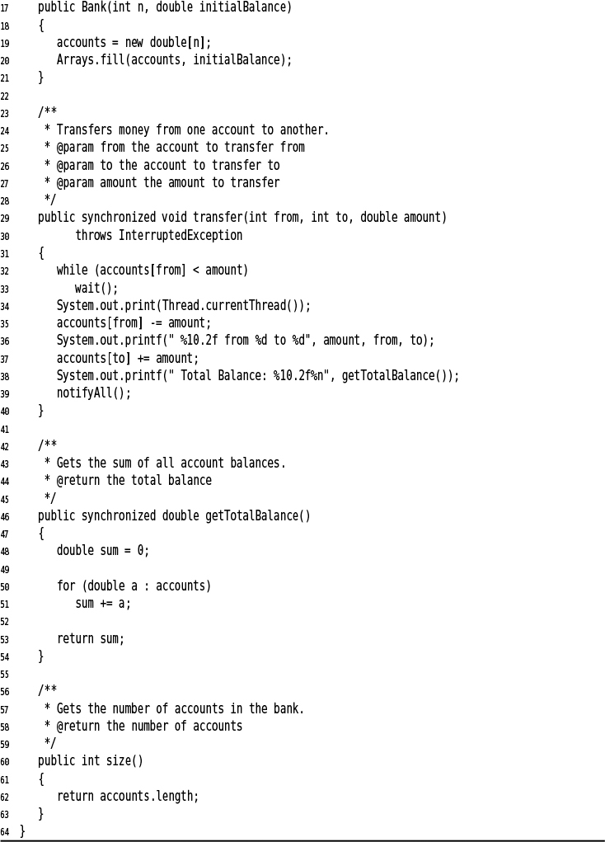

[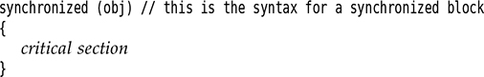](https://learning.oreilly.com/library/view/Core+Java+Volume+I%E2%80%94Fundamentals,+Eleventh+Edition/9780135167199/chapter12.xhtml#p0768_01)

[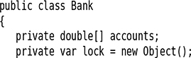](https://learning.oreilly.com/library/view/Core+Java+Volume+I%E2%80%94Fundamentals,+Eleventh+Edition/9780135167199/chapter12.xhtml#p0768_02)

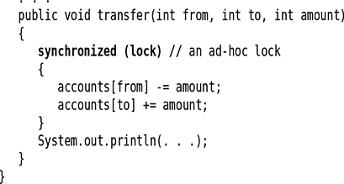

[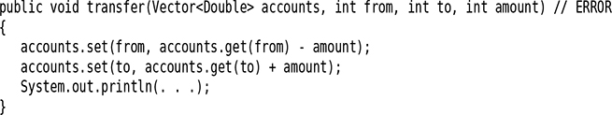](https://learning.oreilly.com/library/view/Core+Java+Volume+I%E2%80%94Fundamentals,+Eleventh+Edition/9780135167199/chapter12.xhtml#p0769_02)

[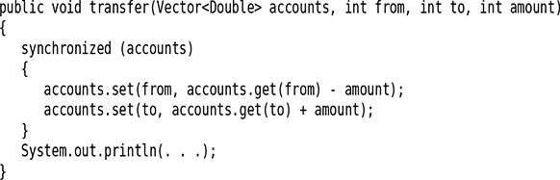](https://learning.oreilly.com/library/view/Core+Java+Volume+I%E2%80%94Fundamentals,+Eleventh+Edition/9780135167199/chapter12.xhtml#p0769_03)

[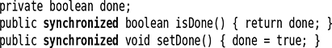](https://learning.oreilly.com/library/view/Core+Java+Volume+I%E2%80%94Fundamentals,+Eleventh+Edition/9780135167199/chapter12.xhtml#p0772_01)

[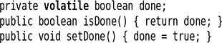](https://learning.oreilly.com/library/view/Core+Java+Volume+I%E2%80%94Fundamentals,+Eleventh+Edition/9780135167199/chapter12.xhtml#p0772_02)

[](https://learning.oreilly.com/library/view/Core+Java+Volume+I%E2%80%94Fundamentals,+Eleventh+Edition/9780135167199/chapter12.xhtml#p0772_03)

[](https://learning.oreilly.com/library/view/Core+Java+Volume+I%E2%80%94Fundamentals,+Eleventh+Edition/9780135167199/chapter12.xhtml#p0772_04)

[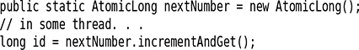](https://learning.oreilly.com/library/view/Core+Java+Volume+I%E2%80%94Fundamentals,+Eleventh+Edition/9780135167199/chapter12.xhtml#p0773_01)

[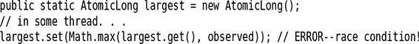](https://learning.oreilly.com/library/view/Core+Java+Volume+I%E2%80%94Fundamentals,+Eleventh+Edition/9780135167199/chapter12.xhtml#p0773_02)

[](https://learning.oreilly.com/library/view/Core+Java+Volume+I%E2%80%94Fundamentals,+Eleventh+Edition/9780135167199/chapter12.xhtml#p0773_03)

[](https://learning.oreilly.com/library/view/Core+Java+Volume+I%E2%80%94Fundamentals,+Eleventh+Edition/9780135167199/chapter12.xhtml#p0773_04)

[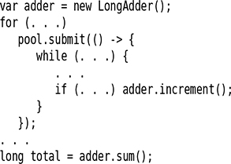](https://learning.oreilly.com/library/view/Core+Java+Volume+I%E2%80%94Fundamentals,+Eleventh+Edition/9780135167199/chapter12.xhtml#p0774_01)

[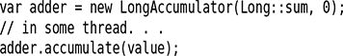](https://learning.oreilly.com/library/view/Core+Java+Volume+I%E2%80%94Fundamentals,+Eleventh+Edition/9780135167199/chapter12.xhtml#p0774_02)

[](https://learning.oreilly.com/library/view/Core+Java+Volume+I%E2%80%94Fundamentals,+Eleventh+Edition/9780135167199/chapter12.xhtml#p0778_01)

[](https://learning.oreilly.com/library/view/Core+Java+Volume+I%E2%80%94Fundamentals,+Eleventh+Edition/9780135167199/chapter12.xhtml#p0778_02)

[](https://learning.oreilly.com/library/view/Core+Java+Volume+I%E2%80%94Fundamentals,+Eleventh+Edition/9780135167199/chapter12.xhtml#p0778_03)

[](https://learning.oreilly.com/library/view/Core+Java+Volume+I%E2%80%94Fundamentals,+Eleventh+Edition/9780135167199/chapter12.xhtml#p0778_04)

[](https://learning.oreilly.com/library/view/Core+Java+Volume+I%E2%80%94Fundamentals,+Eleventh+Edition/9780135167199/chapter12.xhtml#p0778_05)

[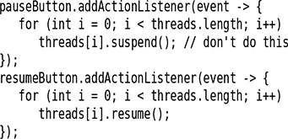](https://learning.oreilly.com/library/view/Core+Java+Volume+I%E2%80%94Fundamentals,+Eleventh+Edition/9780135167199/chapter12.xhtml#p0780_01)

[](https://learning.oreilly.com/library/view/Core+Java+Volume+I%E2%80%94Fundamentals,+Eleventh+Edition/9780135167199/chapter12.xhtml#p0782_01)

[](https://learning.oreilly.com/library/view/Core+Java+Volume+I%E2%80%94Fundamentals,+Eleventh+Edition/9780135167199/chapter12.xhtml#p0782_02)

[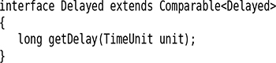](https://learning.oreilly.com/library/view/Core+Java+Volume+I%E2%80%94Fundamentals,+Eleventh+Edition/9780135167199/chapter12.xhtml#p0783_01)

[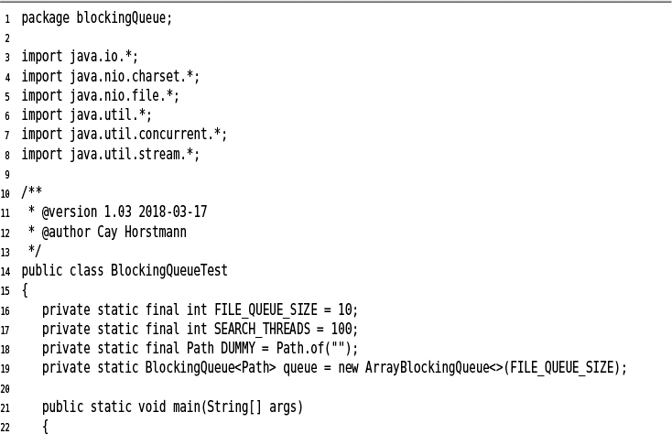](https://learning.oreilly.com/library/view/Core+Java+Volume+I%E2%80%94Fundamentals,+Eleventh+Edition/9780135167199/chapter12.xhtml#c12lis06)

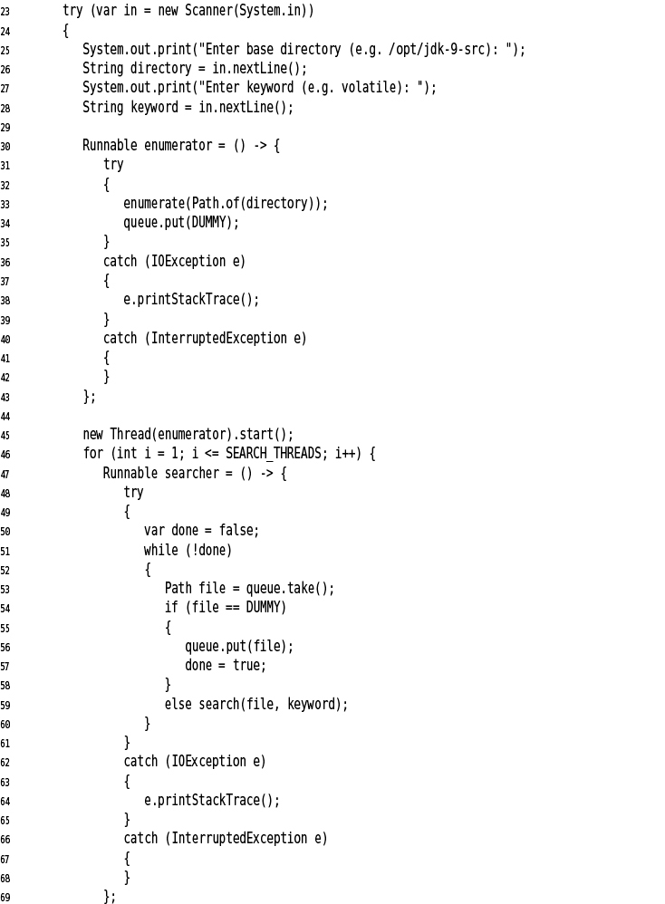

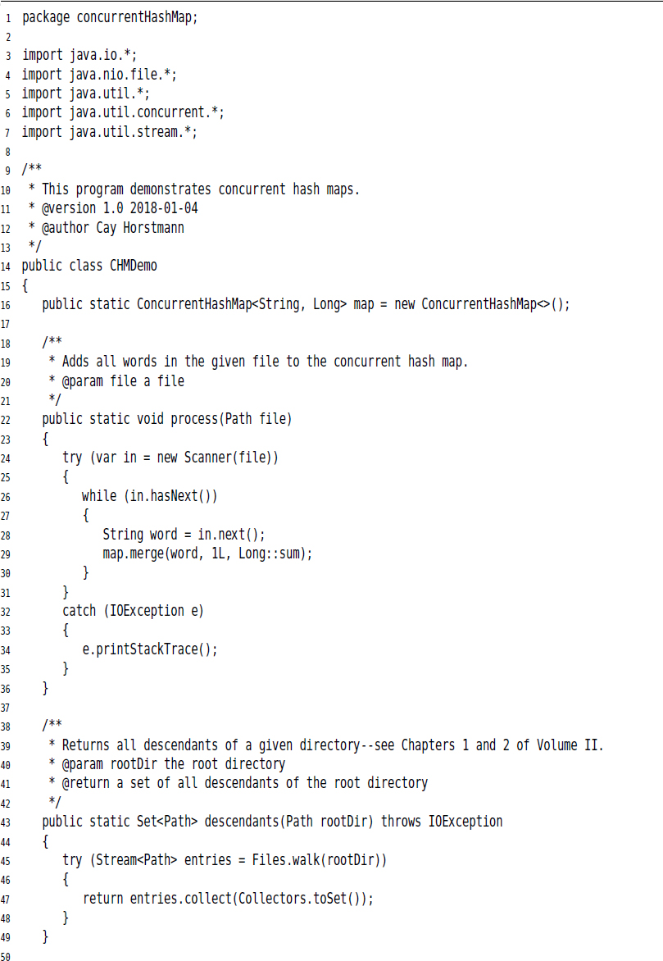

[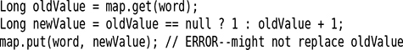](https://learning.oreilly.com/library/view/Core+Java+Volume+I%E2%80%94Fundamentals,+Eleventh+Edition/9780135167199/chapter12.xhtml#p0791_01)

[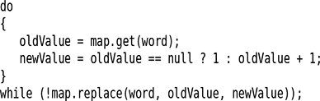](https://learning.oreilly.com/library/view/Core+Java+Volume+I%E2%80%94Fundamentals,+Eleventh+Edition/9780135167199/chapter12.xhtml#p0791_02)

[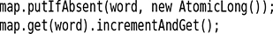](https://learning.oreilly.com/library/view/Core+Java+Volume+I%E2%80%94Fundamentals,+Eleventh+Edition/9780135167199/chapter12.xhtml#p0791_03)

[](https://learning.oreilly.com/library/view/Core+Java+Volume+I%E2%80%94Fundamentals,+Eleventh+Edition/9780135167199/chapter12.xhtml#p0791_04)

[](https://learning.oreilly.com/library/view/Core+Java+Volume+I%E2%80%94Fundamentals,+Eleventh+Edition/9780135167199/chapter12.xhtml#p0792_01)

[](https://learning.oreilly.com/library/view/Core+Java+Volume+I%E2%80%94Fundamentals,+Eleventh+Edition/9780135167199/chapter12.xhtml#p0792_02)

[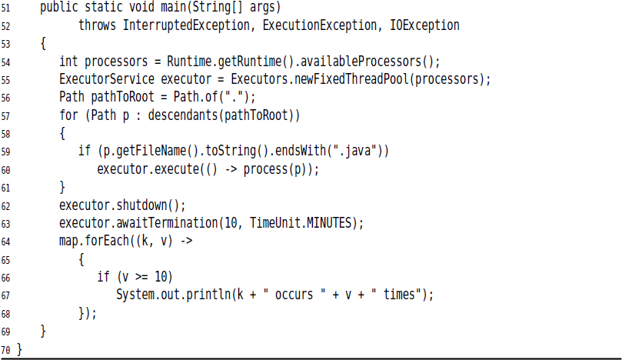](https://learning.oreilly.com/library/view/Core+Java+Volume+I%E2%80%94Fundamentals,+Eleventh+Edition/9780135167199/chapter12.xhtml#c12lis07)

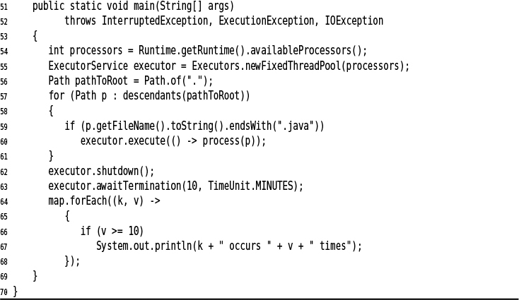

[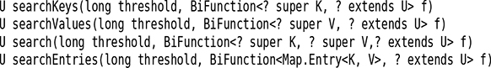](https://learning.oreilly.com/library/view/Core+Java+Volume+I%E2%80%94Fundamentals,+Eleventh+Edition/9780135167199/chapter12.xhtml#p0795_01)

[](https://learning.oreilly.com/library/view/Core+Java+Volume+I%E2%80%94Fundamentals,+Eleventh+Edition/9780135167199/chapter12.xhtml#p0795_02)

[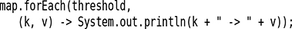](https://learning.oreilly.com/library/view/Core+Java+Volume+I%E2%80%94Fundamentals,+Eleventh+Edition/9780135167199/chapter12.xhtml#p0795_03)

[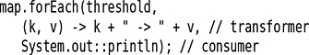](https://learning.oreilly.com/library/view/Core+Java+Volume+I%E2%80%94Fundamentals,+Eleventh+Edition/9780135167199/chapter12.xhtml#p0795_04)

[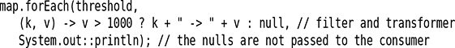](https://learning.oreilly.com/library/view/Core+Java+Volume+I%E2%80%94Fundamentals,+Eleventh+Edition/9780135167199/chapter12.xhtml#p0795_06)

[](https://learning.oreilly.com/library/view/Core+Java+Volume+I%E2%80%94Fundamentals,+Eleventh+Edition/9780135167199/chapter12.xhtml#p0795_07)

[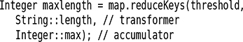](https://learning.oreilly.com/library/view/Core+Java+Volume+I%E2%80%94Fundamentals,+Eleventh+Edition/9780135167199/chapter12.xhtml#p0796_01)

[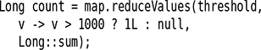](https://learning.oreilly.com/library/view/Core+Java+Volume+I%E2%80%94Fundamentals,+Eleventh+Edition/9780135167199/chapter12.xhtml#p0796_02)

[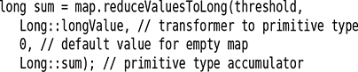](https://learning.oreilly.com/library/view/Core+Java+Volume+I%E2%80%94Fundamentals,+Eleventh+Edition/9780135167199/chapter12.xhtml#p0796_03)

[](https://learning.oreilly.com/library/view/Core+Java+Volume+I%E2%80%94Fundamentals,+Eleventh+Edition/9780135167199/chapter12.xhtml#p0796_04)

[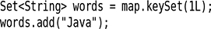](https://learning.oreilly.com/library/view/Core+Java+Volume+I%E2%80%94Fundamentals,+Eleventh+Edition/9780135167199/chapter12.xhtml#p0797_01)

[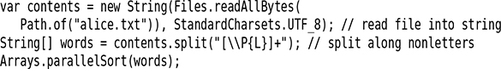](https://learning.oreilly.com/library/view/Core+Java+Volume+I%E2%80%94Fundamentals,+Eleventh+Edition/9780135167199/chapter12.xhtml#p0797_02)

[](https://learning.oreilly.com/library/view/Core+Java+Volume+I%E2%80%94Fundamentals,+Eleventh+Edition/9780135167199/chapter12.xhtml#p0797_03)

[](https://learning.oreilly.com/library/view/Core+Java+Volume+I%E2%80%94Fundamentals,+Eleventh+Edition/9780135167199/chapter12.xhtml#p0797_04)

[](https://learning.oreilly.com/library/view/Core+Java+Volume+I%E2%80%94Fundamentals,+Eleventh+Edition/9780135167199/chapter12.xhtml#p0798_01)

[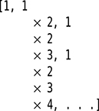](https://learning.oreilly.com/library/view/Core+Java+Volume+I%E2%80%94Fundamentals,+Eleventh+Edition/9780135167199/chapter12.xhtml#p0798_02)

[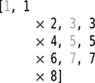](https://learning.oreilly.com/library/view/Core+Java+Volume+I%E2%80%94Fundamentals,+Eleventh+Edition/9780135167199/chapter12.xhtml#p0798_03)

[](https://learning.oreilly.com/library/view/Core+Java+Volume+I%E2%80%94Fundamentals,+Eleventh+Edition/9780135167199/chapter12.xhtml#p0798_04)

[](https://learning.oreilly.com/library/view/Core+Java+Volume+I%E2%80%94Fundamentals,+Eleventh+Edition/9780135167199/chapter12.xhtml#p0799_01)

[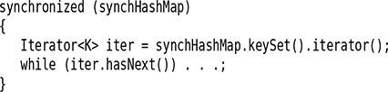](https://learning.oreilly.com/library/view/Core+Java+Volume+I%E2%80%94Fundamentals,+Eleventh+Edition/9780135167199/chapter12.xhtml#p0799_02)

[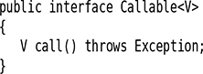](https://learning.oreilly.com/library/view/Core+Java+Volume+I%E2%80%94Fundamentals,+Eleventh+Edition/9780135167199/chapter12.xhtml#p0800_01)

[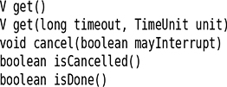](https://learning.oreilly.com/library/view/Core+Java+Volume+I%E2%80%94Fundamentals,+Eleventh+Edition/9780135167199/chapter12.xhtml#p0801_01)

[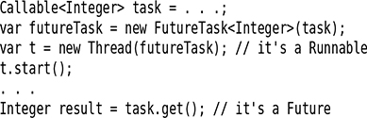](https://learning.oreilly.com/library/view/Core+Java+Volume+I%E2%80%94Fundamentals,+Eleventh+Edition/9780135167199/chapter12.xhtml#p0801_02)

[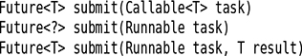](https://learning.oreilly.com/library/view/Core+Java+Volume+I%E2%80%94Fundamentals,+Eleventh+Edition/9780135167199/chapter12.xhtml#p0803_01)

[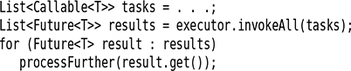](https://learning.oreilly.com/library/view/Core+Java+Volume+I%E2%80%94Fundamentals,+Eleventh+Edition/9780135167199/chapter12.xhtml#p0806_01)

[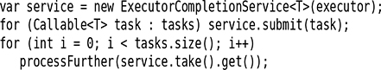](https://learning.oreilly.com/library/view/Core+Java+Volume+I%E2%80%94Fundamentals,+Eleventh+Edition/9780135167199/chapter12.xhtml#p0806_02)

[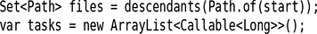](https://learning.oreilly.com/library/view/Core+Java+Volume+I%E2%80%94Fundamentals,+Eleventh+Edition/9780135167199/chapter12.xhtml#p0806_03)

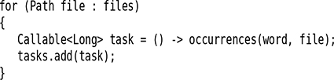

[](https://learning.oreilly.com/library/view/Core+Java+Volume+I%E2%80%94Fundamentals,+Eleventh+Edition/9780135167199/chapter12.xhtml#p0807_02)

[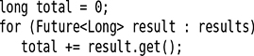](https://learning.oreilly.com/library/view/Core+Java+Volume+I%E2%80%94Fundamentals,+Eleventh+Edition/9780135167199/chapter12.xhtml#p0807_03)

[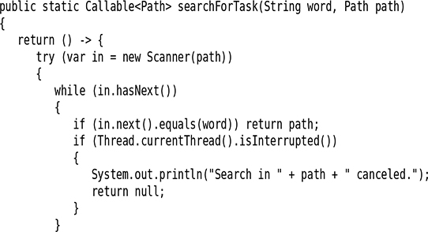](https://learning.oreilly.com/library/view/Core+Java+Volume+I%E2%80%94Fundamentals,+Eleventh+Edition/9780135167199/chapter12.xhtml#p0807_04)

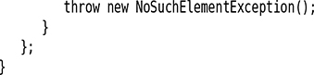

[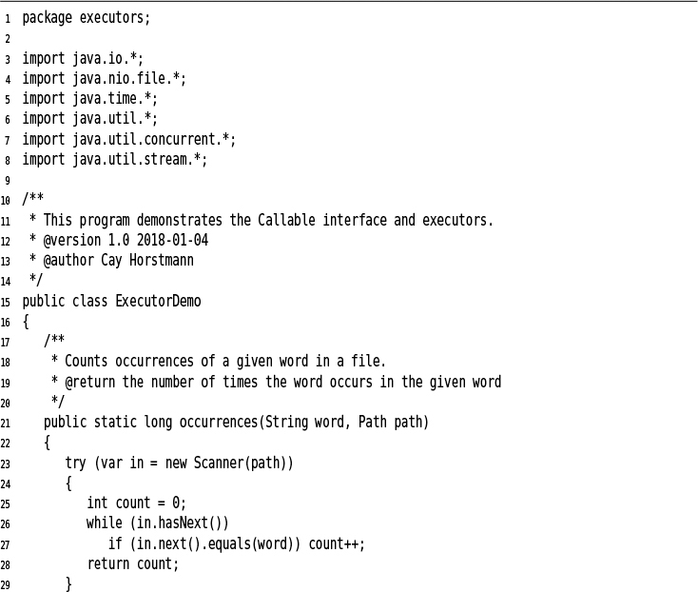](https://learning.oreilly.com/library/view/Core+Java+Volume+I%E2%80%94Fundamentals,+Eleventh+Edition/9780135167199/chapter12.xhtml#c12lis08)

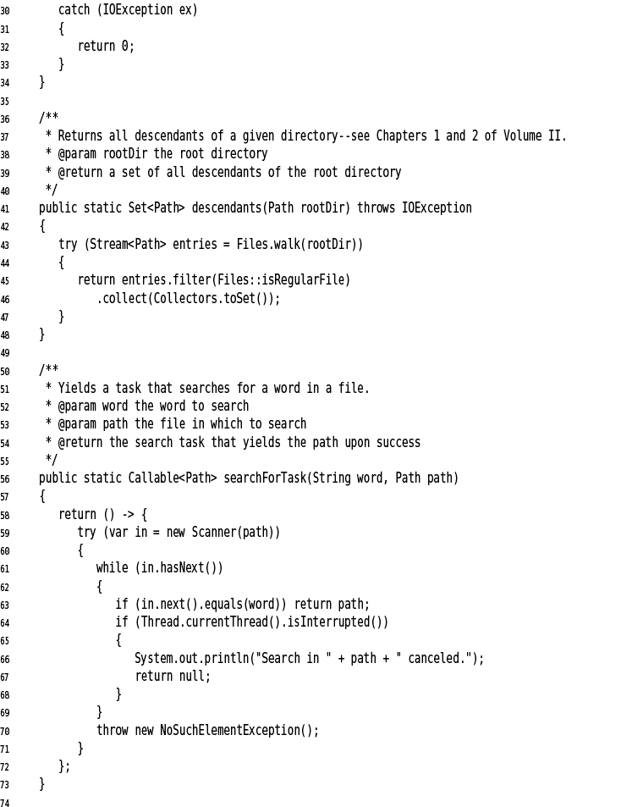

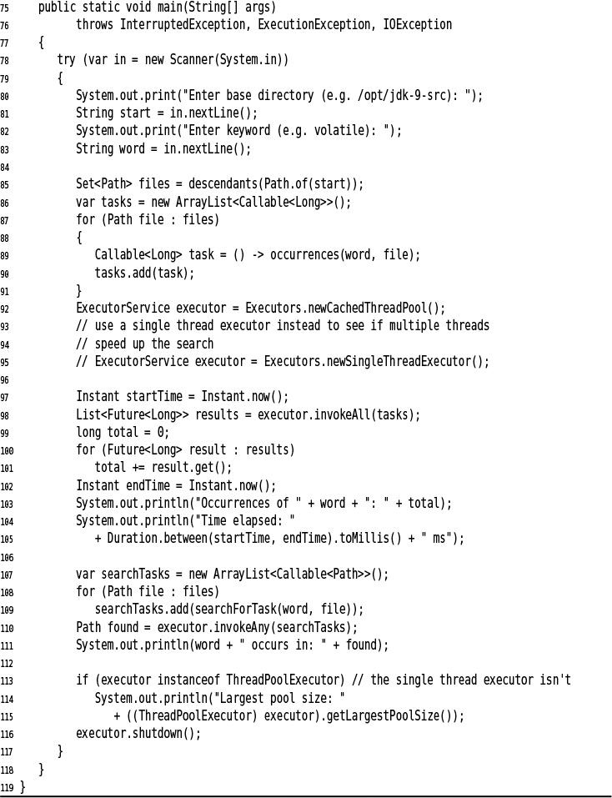

[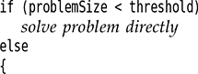](https://learning.oreilly.com/library/view/Core+Java+Volume+I%E2%80%94Fundamentals,+Eleventh+Edition/9780135167199/chapter12.xhtml#p0811_01)

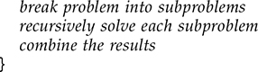

[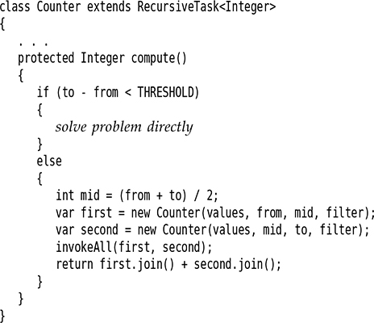](https://learning.oreilly.com/library/view/Core+Java+Volume+I%E2%80%94Fundamentals,+Eleventh+Edition/9780135167199/chapter12.xhtml#p0812_02)

[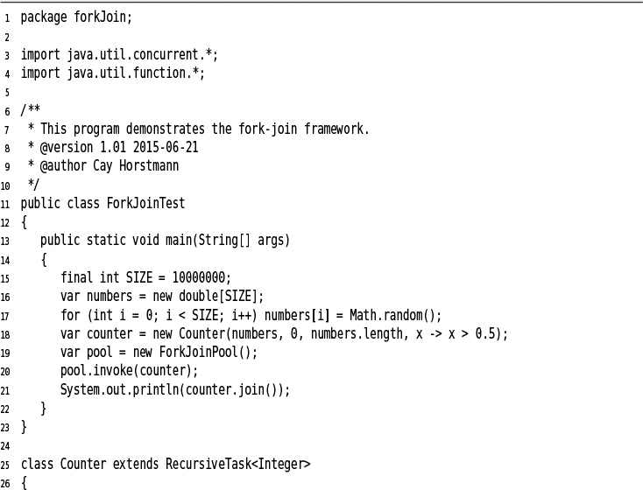](https://learning.oreilly.com/library/view/Core+Java+Volume+I%E2%80%94Fundamentals,+Eleventh+Edition/9780135167199/chapter12.xhtml#c12lis09)

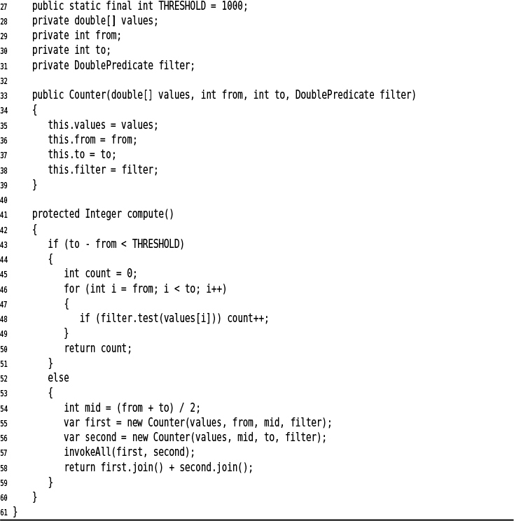

[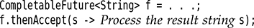](https://learning.oreilly.com/library/view/Core+Java+Volume+I%E2%80%94Fundamentals,+Eleventh+Edition/9780135167199/chapter12.xhtml#p0815_01)

[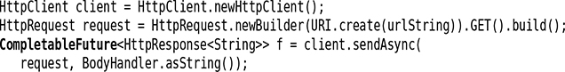](https://learning.oreilly.com/library/view/Core+Java+Volume+I%E2%80%94Fundamentals,+Eleventh+Edition/9780135167199/chapter12.xhtml#p0815_02)

[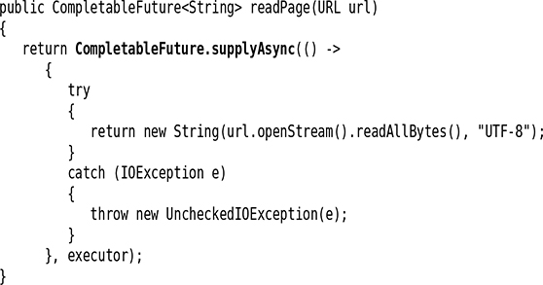](https://learning.oreilly.com/library/view/Core+Java+Volume+I%E2%80%94Fundamentals,+Eleventh+Edition/9780135167199/chapter12.xhtml#p0815_03)

[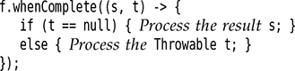](https://learning.oreilly.com/library/view/Core+Java+Volume+I%E2%80%94Fundamentals,+Eleventh+Edition/9780135167199/chapter12.xhtml#p0816_01)

[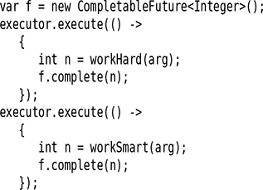](https://learning.oreilly.com/library/view/Core+Java+Volume+I%E2%80%94Fundamentals,+Eleventh+Edition/9780135167199/chapter12.xhtml#p0816_02)

[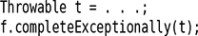](https://learning.oreilly.com/library/view/Core+Java+Volume+I%E2%80%94Fundamentals,+Eleventh+Edition/9780135167199/chapter12.xhtml#p0816_03)

[](https://learning.oreilly.com/library/view/Core+Java+Volume+I%E2%80%94Fundamentals,+Eleventh+Edition/9780135167199/chapter12.xhtml#p0817_01)

[](https://learning.oreilly.com/library/view/Core+Java+Volume+I%E2%80%94Fundamentals,+Eleventh+Edition/9780135167199/chapter12.xhtml#p0817_02)

[](https://learning.oreilly.com/library/view/Core+Java+Volume+I%E2%80%94Fundamentals,+Eleventh+Edition/9780135167199/chapter12.xhtml#p0817_03)

[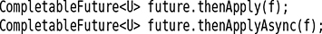](https://learning.oreilly.com/library/view/Core+Java+Volume+I%E2%80%94Fundamentals,+Eleventh+Edition/9780135167199/chapter12.xhtml#p0818_01)

[](https://learning.oreilly.com/library/view/Core+Java+Volume+I%E2%80%94Fundamentals,+Eleventh+Edition/9780135167199/chapter12.xhtml#p0818_02)

[](https://learning.oreilly.com/library/view/Core+Java+Volume+I%E2%80%94Fundamentals,+Eleventh+Edition/9780135167199/chapter12.xhtml#p0818_03)

[](https://learning.oreilly.com/library/view/Core+Java+Volume+I%E2%80%94Fundamentals,+Eleventh+Edition/9780135167199/chapter12.xhtml#p0818_04)

[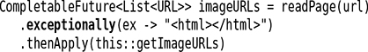](https://learning.oreilly.com/library/view/Core+Java+Volume+I%E2%80%94Fundamentals,+Eleventh+Edition/9780135167199/chapter12.xhtml#p0819_01)

[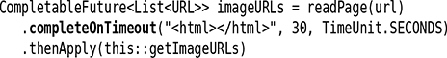](https://learning.oreilly.com/library/view/Core+Java+Volume+I%E2%80%94Fundamentals,+Eleventh+Edition/9780135167199/chapter12.xhtml#p0819_02)

[](https://learning.oreilly.com/library/view/Core+Java+Volume+I%E2%80%94Fundamentals,+Eleventh+Edition/9780135167199/chapter12.xhtml#p0819_03)

[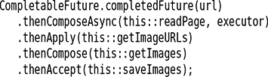](https://learning.oreilly.com/library/view/Core+Java+Volume+I%E2%80%94Fundamentals,+Eleventh+Edition/9780135167199/chapter12.xhtml#p0821_01)

[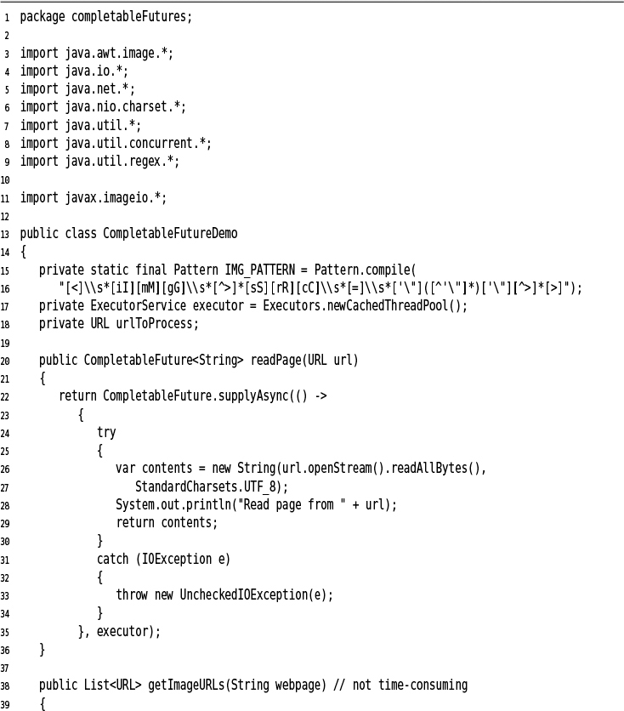](https://learning.oreilly.com/library/view/Core+Java+Volume+I%E2%80%94Fundamentals,+Eleventh+Edition/9780135167199/chapter12.xhtml#c12lis10)

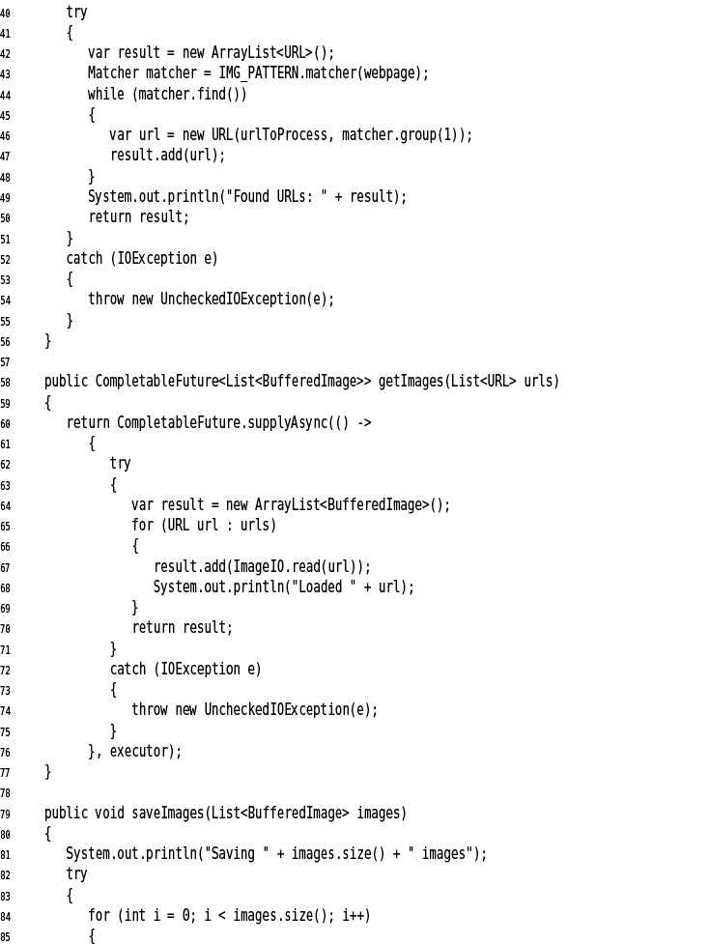

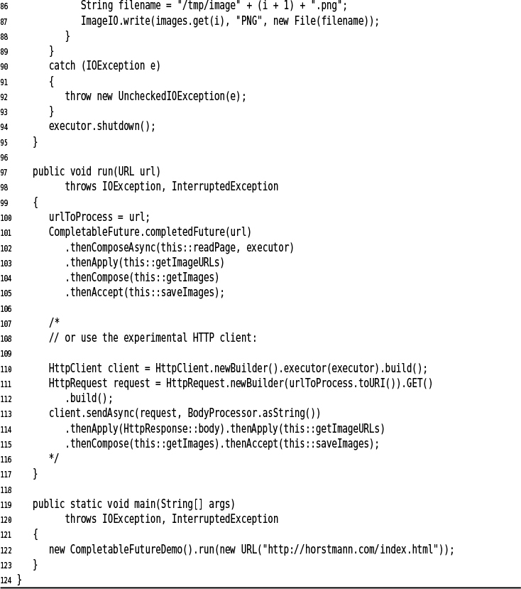

[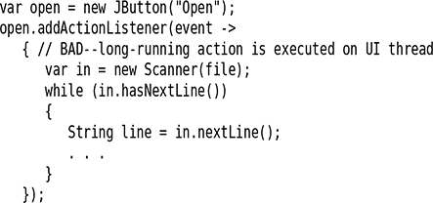](https://learning.oreilly.com/library/view/Core+Java+Volume+I%E2%80%94Fundamentals,+Eleventh+Edition/9780135167199/chapter12.xhtml#p0824_01)

[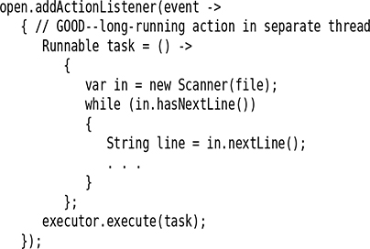](https://learning.oreilly.com/library/view/Core+Java+Volume+I%E2%80%94Fundamentals,+Eleventh+Edition/9780135167199/chapter12.xhtml#p0824_02)

[](https://learning.oreilly.com/library/view/Core+Java+Volume+I%E2%80%94Fundamentals,+Eleventh+Edition/9780135167199/chapter12.xhtml#p0824_03)

[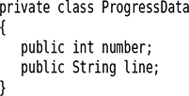](https://learning.oreilly.com/library/view/Core+Java+Volume+I%E2%80%94Fundamentals,+Eleventh+Edition/9780135167199/chapter12.xhtml#p0826_01)

[](https://learning.oreilly.com/library/view/Core+Java+Volume+I%E2%80%94Fundamentals,+Eleventh+Edition/9780135167199/chapter12.xhtml#p0826_02)

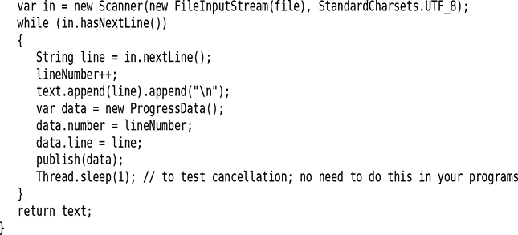

[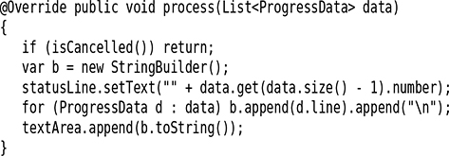](https://learning.oreilly.com/library/view/Core+Java+Volume+I%E2%80%94Fundamentals,+Eleventh+Edition/9780135167199/chapter12.xhtml#p0827_02)

[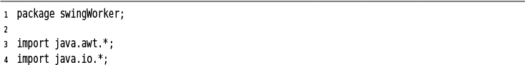](https://learning.oreilly.com/library/view/Core+Java+Volume+I%E2%80%94Fundamentals,+Eleventh+Edition/9780135167199/chapter12.xhtml#c12lis11)

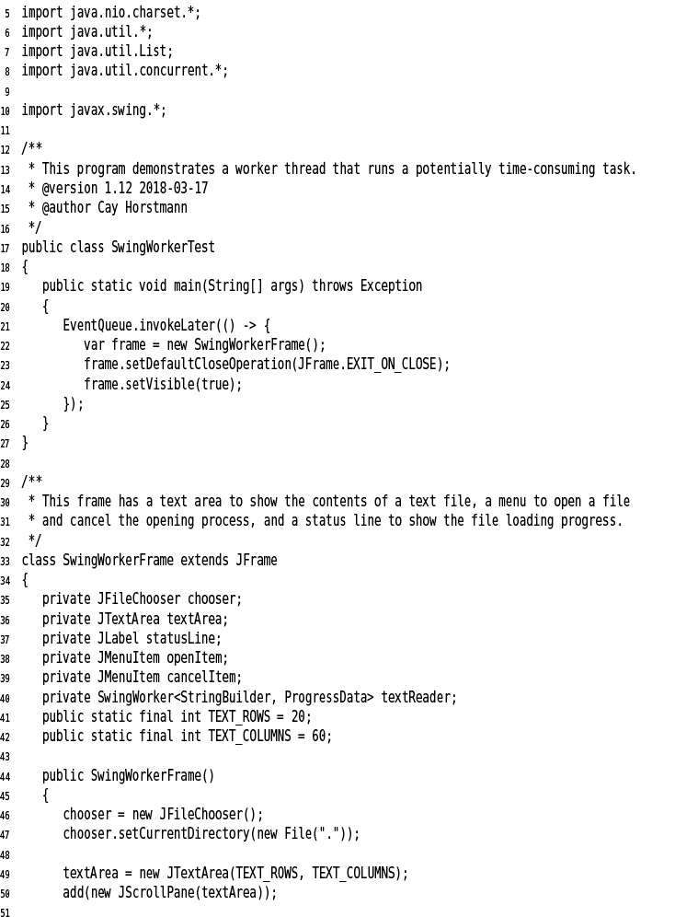

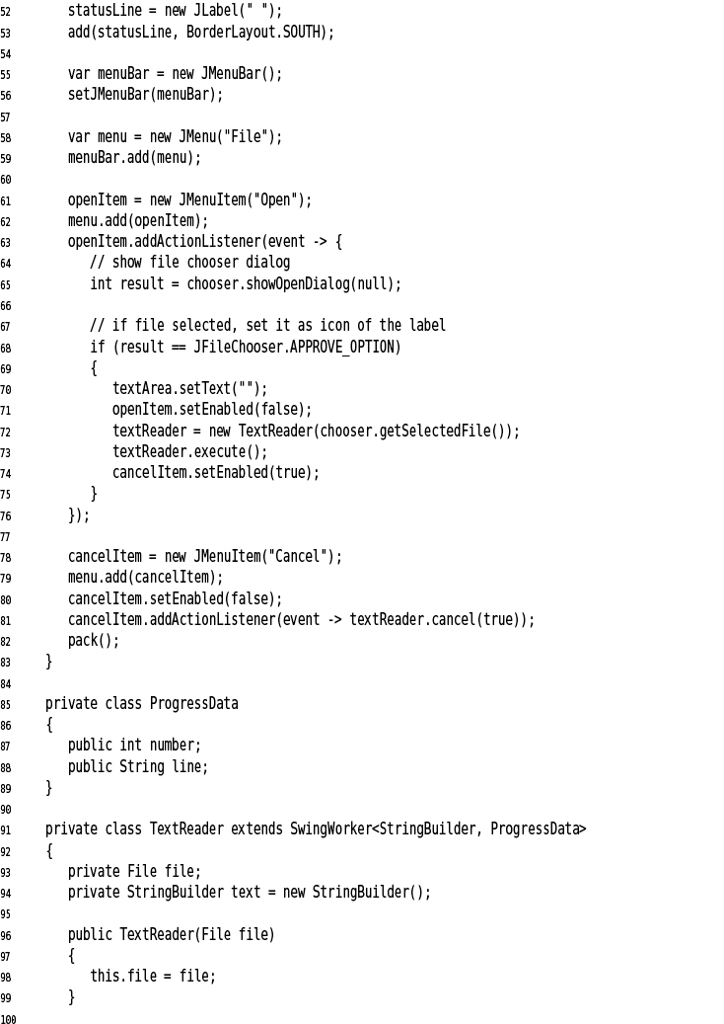

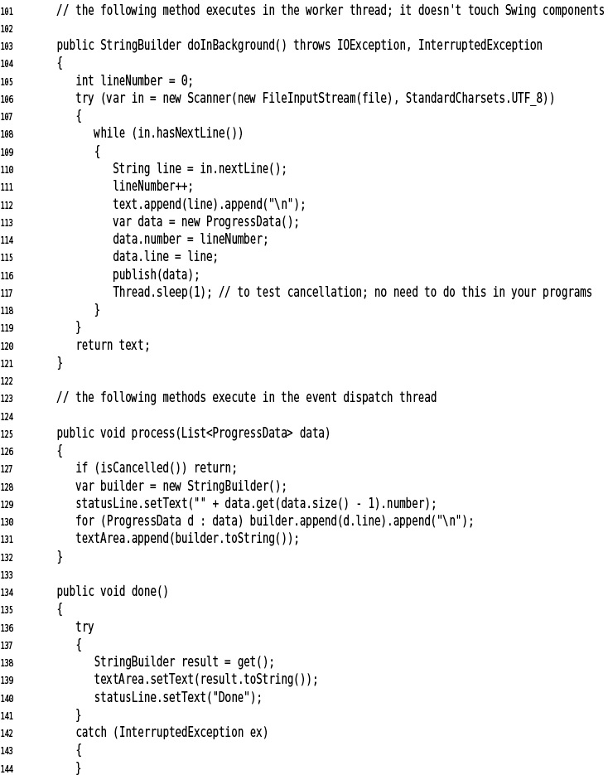

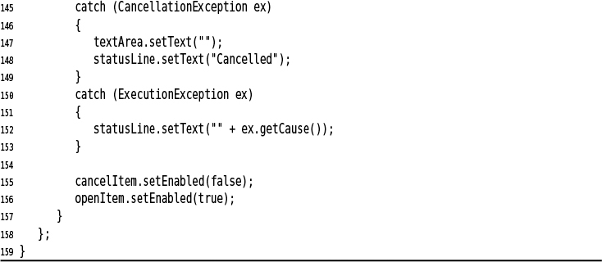

[](https://learning.oreilly.com/library/view/Core+Java+Volume+I%E2%80%94Fundamentals,+Eleventh+Edition/9780135167199/chapter12.xhtml#p0832_01)

[](https://learning.oreilly.com/library/view/Core+Java+Volume+I%E2%80%94Fundamentals,+Eleventh+Edition/9780135167199/chapter12.xhtml#p0832_02)

[](https://learning.oreilly.com/library/view/Core+Java+Volume+I%E2%80%94Fundamentals,+Eleventh+Edition/9780135167199/chapter12.xhtml#p0832_00)

[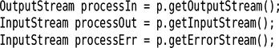](https://learning.oreilly.com/library/view/Core+Java+Volume+I%E2%80%94Fundamentals,+Eleventh+Edition/9780135167199/chapter12.xhtml#p0832_03)

[](https://learning.oreilly.com/library/view/Core+Java+Volume+I%E2%80%94Fundamentals,+Eleventh+Edition/9780135167199/chapter12.xhtml#p0833_03)

[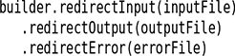](https://learning.oreilly.com/library/view/Core+Java+Volume+I%E2%80%94Fundamentals,+Eleventh+Edition/9780135167199/chapter12.xhtml#p0833_04)

[](https://learning.oreilly.com/library/view/Core+Java+Volume+I%E2%80%94Fundamentals,+Eleventh+Edition/9780135167199/chapter12.xhtml#p0833_05)

[](https://learning.oreilly.com/library/view/Core+Java+Volume+I%E2%80%94Fundamentals,+Eleventh+Edition/9780135167199/chapter12.xhtml#p0833_06)

[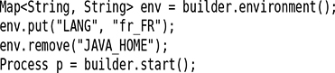](https://learning.oreilly.com/library/view/Core+Java+Volume+I%E2%80%94Fundamentals,+Eleventh+Edition/9780135167199/chapter12.xhtml#p0833_07)

[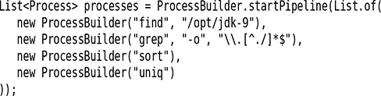](https://learning.oreilly.com/library/view/Core+Java+Volume+I%E2%80%94Fundamentals,+Eleventh+Edition/9780135167199/chapter12.xhtml#p0833_08)



[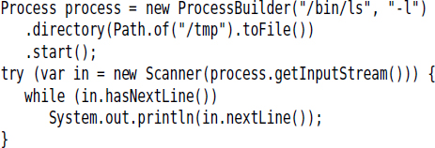](https://learning.oreilly.com/library/view/Core+Java+Volume+I%E2%80%94Fundamentals,+Eleventh+Edition/9780135167199/chapter12.xhtml#p0834_01)

[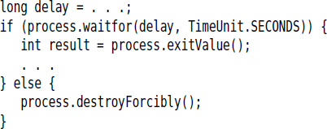](https://learning.oreilly.com/library/view/Core+Java+Volume+I%E2%80%94Fundamentals,+Eleventh+Edition/9780135167199/chapter12.xhtml#p0834_02)

[](https://learning.oreilly.com/library/view/Core+Java+Volume+I%E2%80%94Fundamentals,+Eleventh+Edition/9780135167199/chapter12.xhtml#p0835_01)

[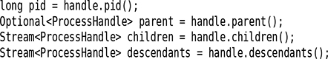](https://learning.oreilly.com/library/view/Core+Java+Volume+I%E2%80%94Fundamentals,+Eleventh+Edition/9780135167199/chapter12.xhtml#p0835_02)

[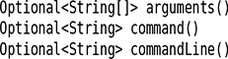](https://learning.oreilly.com/library/view/Core+Java+Volume+I%E2%80%94Fundamentals,+Eleventh+Edition/9780135167199/chapter12.xhtml#p0835_03)

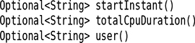

[back to top](https://learning.oreilly.com/library/view/Core+Java+Volume+I%E2%80%94Fundamentals,+Eleventh+Edition/9780135167199/chapter12_images.xhtml)

* [Settings](https://learning.oreilly.com/u/preferences/)

* [Support](https://learning.oreilly.com/public/support/)

* [Sign Out](https://learning.oreilly.com/accounts/logout/)

© 2020 [O'Reilly Media, Inc](https://learning.oreilly.com/). [Terms of Service](https://www.oreilly.com/terms/) / [Privacy Policy](https://learning.oreilly.com/privacy)